**NAINCY THAPA**

**IT 520- Lab 3**

**March 18th, 2019**

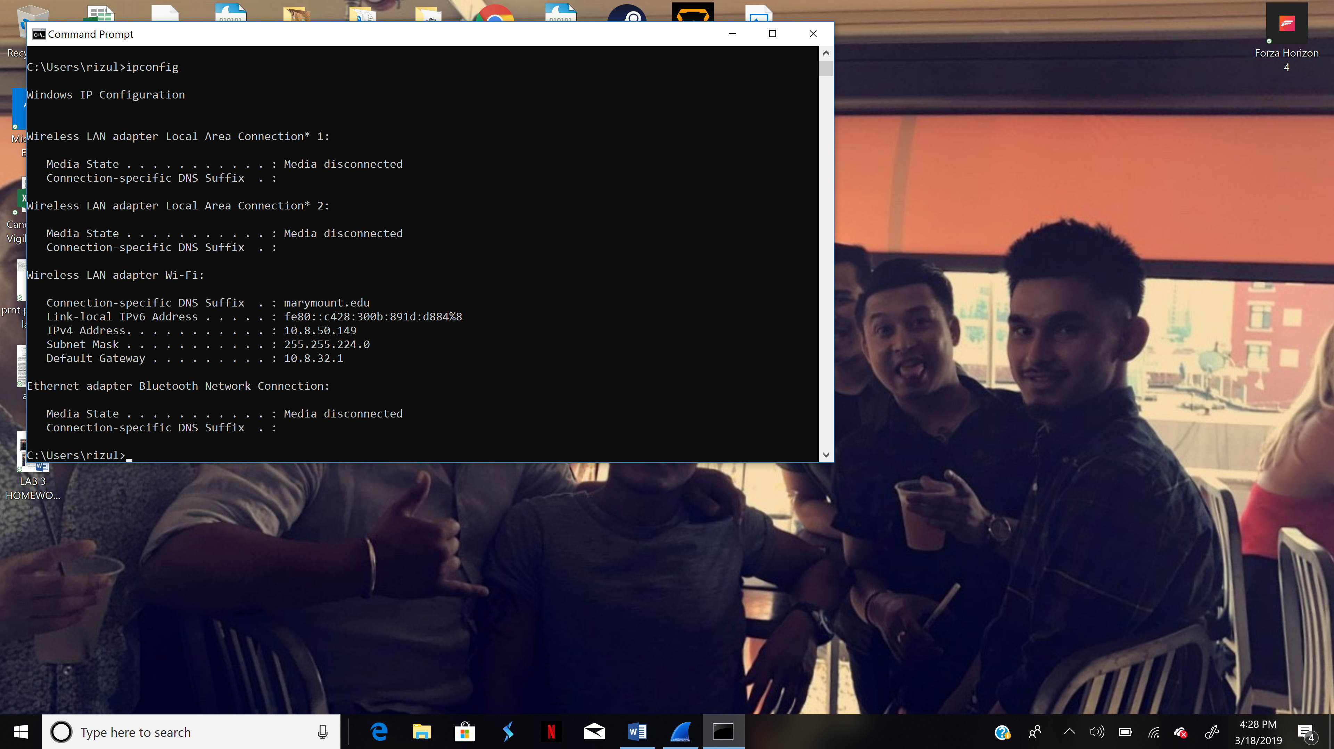



1. **What is the TCP port number used by your computer to communicate with gaia.cs.umass.edu?**

**TCP port no.: 50720**

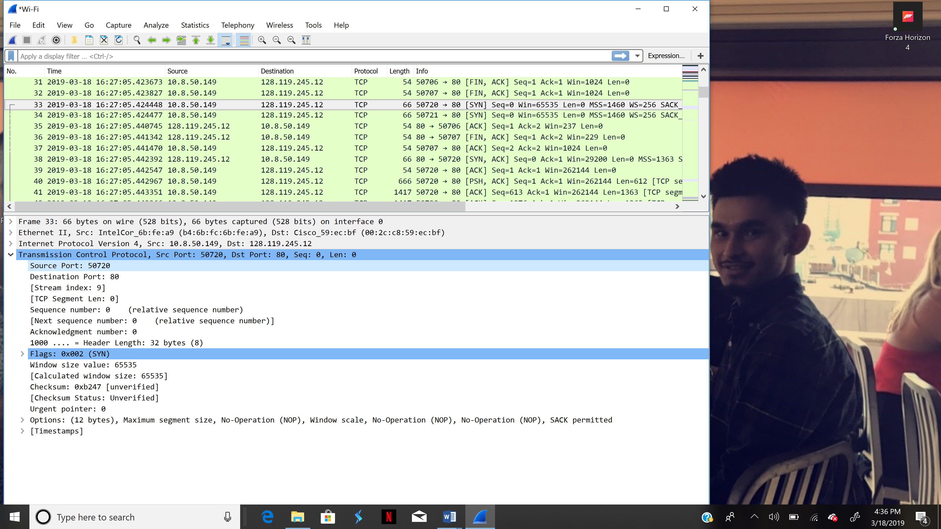

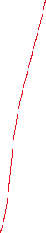

1. **What is the TCP port number used by gaia.cs.umass.edu to communicate with your computer?**

**TCP PORT NO.-80**

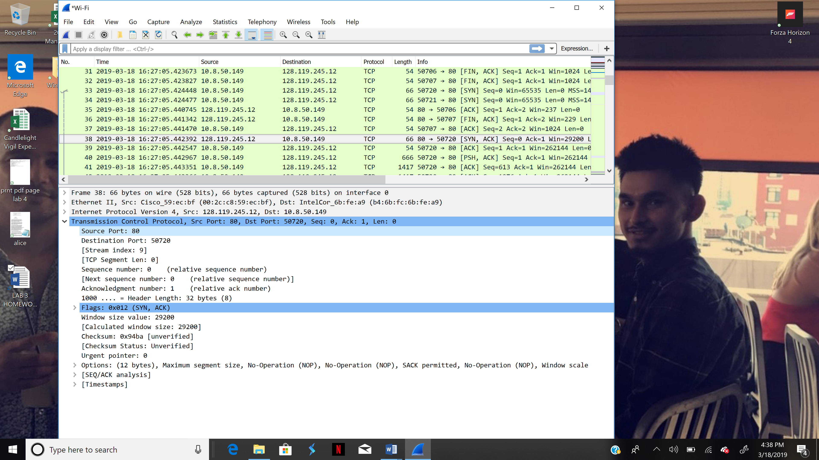



1. **What is the sequence number of the TCP SYN segment that is used to initiate the TCP connection between your computer and gaia.cs.umass.edu? What is it in the segment that identifies the segment as a SYN segment?**

**Seq no.:0**

**SYN flag is set to 0 and it indicates that this segment is a SYN segment.**

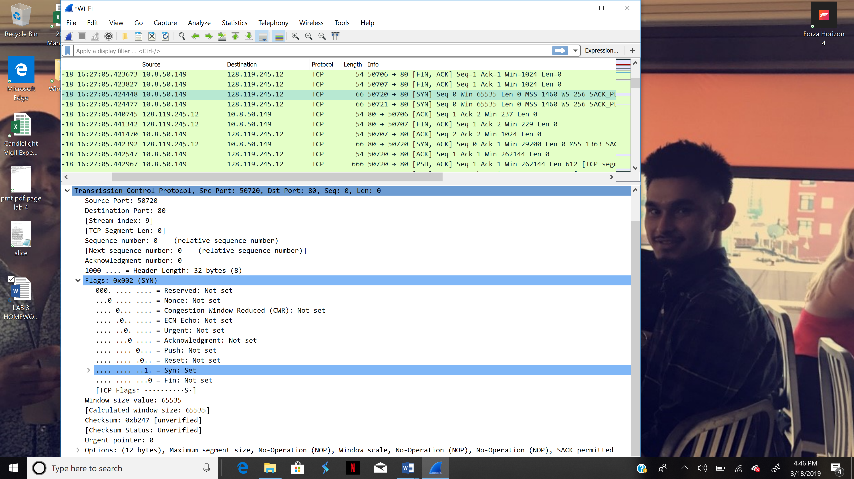



1. **What is the sequence number of the SYNACK segment sent by gaia.cs.umass.edu to the client computer in reply to the SYN? - You must dig deep and find the ACK from gaia.cs.umass.edu.**

**0**

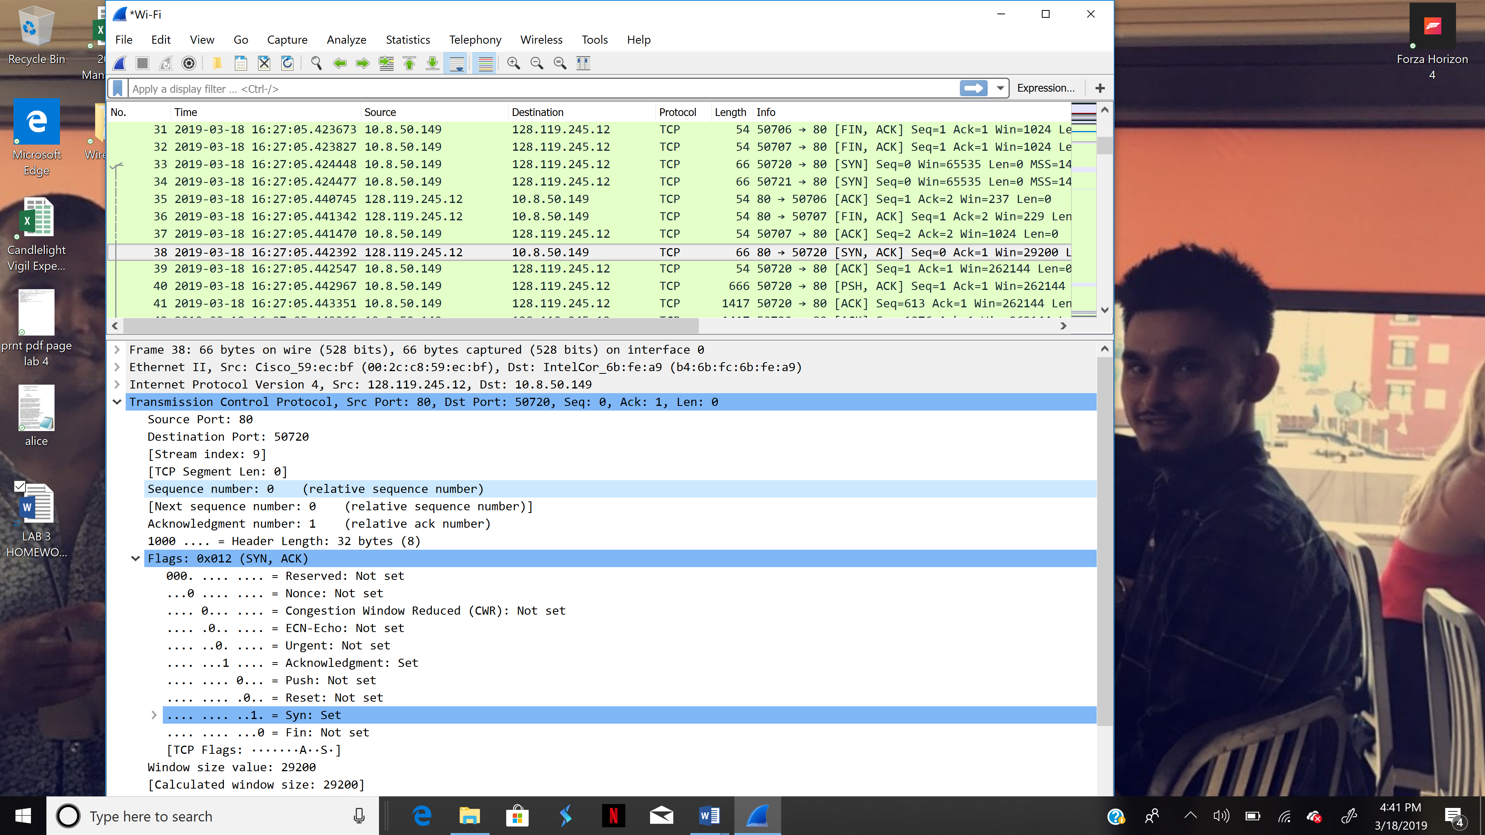



1. **What is the sequence number of the TCP segment containing the HTTP POST command? Note: that to find the POST command, you’ll need to dig into the packet content field at the bottom of the Wireshark window, looking for a segment with a “POST” within its DATA field.**

**Seq no.: 151906**

